

TTII CRYSTAL BRIGHT SPECIFICATION
PHYSIAT
Produced and Distributed from Lake Wales, FL

SUPPLIER: Target Technologies International Inc
GRADATION: 16-30 & 30-50 (20-40 special order)
SAND PHYSICAL PROPERTIES:

Shape: sub round to sub angular
Color: white
Mohs Hardness: 7
Specific Gravity: 2.65
Si02: 99.59
COATING PHYSICAL PROPERTIES:

Non microplastic acrylic coating
UV resistant
Stain resistant
Water resistant
Antimicrobial APEO Free, formaldehyde
free, low VOC
Colors: Full Green and Frosted Green

TESTING:

- EPA 1633 PFAS Testing
- ASTM F3188 Toxicology
- EN-71-3 Toxicology
- EPA6020B CAM 17 Toxicology
- PAH’s Toxicology
- Lisport

TYPICAL SIEVE ANALYSIS:
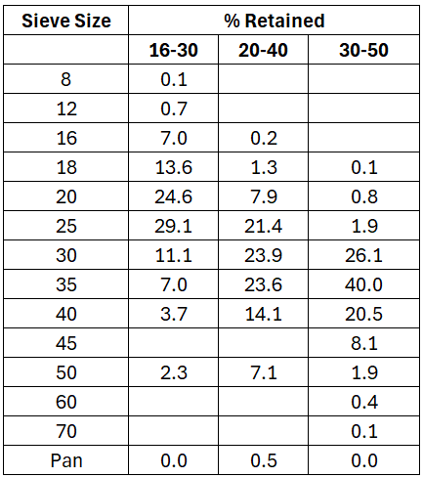

July 6, 2026

